HTTPS not working, even if the functional test completes with all green

Troubleshooting steps

1. Logon to the eblocker settings and go to the devices
2. Select the device which is not working with eblocker
3. Write down any special setting for this device
4. Click on “RESET DEVICE”  
   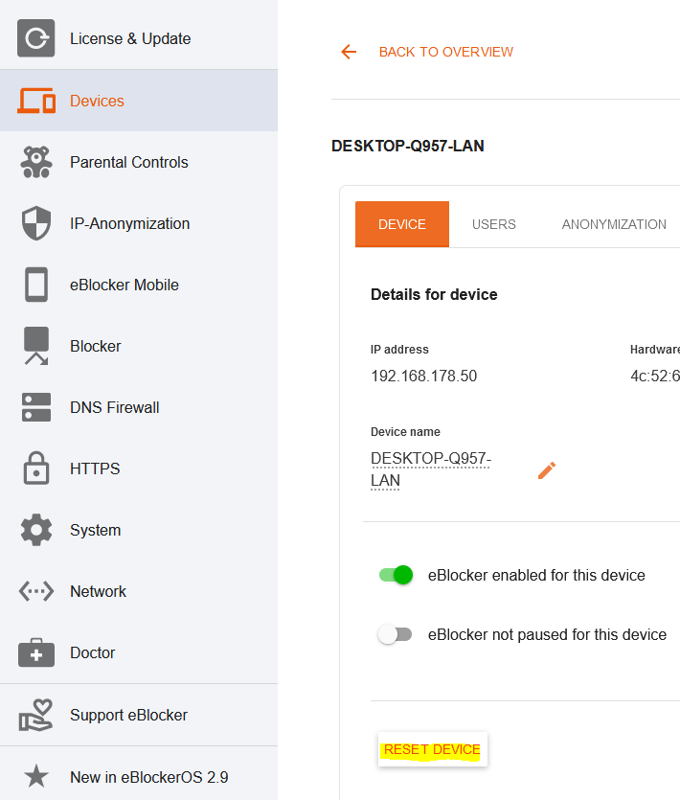
5. After this, the device will be shown as new device with eblocker disabled.
6. Enable eblocker and configure it again as needed
7. Test the websites, which were not working before